INTERNATIONAL INSTITUTE OF MEDICAL SCIENCE
AND TECHNOLOGY COUNCIL

FOOD WASTE REDUCTION SYSTEM
SDG 12 - Responsible Consumption and Production

Team Members

USN | Name
1DB22CS169  3DG22AD019  4VM22IS004  1RI22CS108  1EW22IC020  1ICS23EC405  2BU22CS072  1RI22CS072  1AP22EC029  2BU22AD016  1MP22CS009  1RL22CDO62  1RL22CD055 | Tashwin J  Jacklene Sharon  Zakia  Adeeba Siddiquie  Jaivanth S  Gopi  Mariah  Ashwini Bai E  Satish patil  Israrahamed Ibrahim Shigehalli  Ayesha Muskan  Y.Jessika rani  V.Moksha Mukunda Priya

COHORT 11
Submission Date: 3rd March of 2026

ACKNOWLEDGEMENT

First and foremost, we sincerely thank the management and coordinators of the International Institute of Medical Science and Technology Council for providing us with this wonderful opportunity to work on a socially relevant and impactful project. The platform provided by the institute allowed us to explore practical applications of data science in addressing real-world environmental challenges.
We would like to express our heartfelt gratitude to everyone who supported and guided us throughout the successful completion of our project titled “E-Waste
Generation Prediction.” This project, aligned with SDG 12 – Responsible Consumption and Production, has been a valuable learning experience.
We extend our deepest appreciation to our mentor and supervisors for their continuous guidance, constructive feedback. Their expert insights helped us understand complex concepts in data preprocessing, feature selection, model building, and evaluation.
We are also grateful to our internship coordinators for organizing structured sessions.
Their support helped us stay aligned with project objectives and deadlines.
Special thanks to our team members for their dedication, collaboration, and teamwork. From data collection and cleaning to implementing machine learning models and interpreting results, each member contributed responsibly and efficiently. The coordination, idea sharing, and problem-solving spirit within the team greatly enhanced the overall outcome of the project.
We would also like to acknowledge the online platforms, research articles, and open datasets that provided essential information and resources for our analysis. These references strengthened the foundation of our model and enhanced our understanding of e-waste generation patterns.
Finally, we express our sincere gratitude to everyone who directly or indirectly supported us during this internship journey. The experience has significantly enhanced our technical skills, research abilities, teamwork.

ABSTRACT
Food waste is a major global issue affecting economic stability, food security, and environmental sustainability. Retail outlets and supermarkets often struggle to manage inventory efficiently, leading to excess spoilage and waste.
This project proposes a Food Waste Prediction System using Machine Learning to estimate food waste (in kg) based on retail inventory features. The model uses a Random Forest Regressor trained on structured retail data to accurately predict the amount of food waste generated.
The system achieved:
- Mean Absolute Error (MAE): 0.6255 kg
- R² Score: 0.9923 (99.23% Accuracy)
This indicates high prediction accuracy and strong practical applicability in retail environments.
The Food Waste Reduction System is a Machine Learning-based predictive model designed to estimate food waste levels using inventory-related parameters such as inventory turnover, shelf life, and storage duration. By applying regression analysis, the system identifies patterns in historical data and predicts the amount of waste likely to occur.
This project aligns with the sustainability goals promoted by the United Nations Sustainable Development Goal 12 (Responsible Consumption and Production), which emphasizes reducing global food waste. The proposed solution demonstrates how data-driven decision-making can support efficient inventory control and sustainable retail management.

By analyzing the effectiveness of random forests, this research highlights the ability of these models to enhance forecasting accuracy and waste management efficiency. Findings underscore the potential of ML to support sustainable food consumption, reduce waste generation, and achieve environmental benefits. This research offers insights into the practical deployment of ML for food waste mitigation, providing a roadmap for stakeholders aiming to adopt technology-driven waste reduction strategies.

INTRODUCTION
Food waste is one of the major global challenges affecting economic stability, environmental sustainability, and food security. Large amounts of food are wasted due to poor inventory management, overstocking, inaccurate demand forecasting, and improper storage.
This project aims to develop a Food Waste Reduction System using Machine Learning techniques to predict the amount of food waste (in kg) based on inventory and sales-related features.
The system helps businesses:
- Reduce unnecessary food waste
- Improve inventory planning
- Increase profitability
Traditional inventory systems rely heavily on manual monitoring and historical assumptions, which may not accurately predict future waste levels. With advancements in data science and machine learning, predictive analytics can be applied to forecast potential waste before it occurs.
The Food Waste Reduction System leverages machine learning techniques to analyze inventory-related features and predict food waste quantities. By understanding the relationship between storage time, turnover rate, and shelf life, the system assists retailers in making informed decisions that reduce losses and improve sustainability.
This project highlights the importance of integrating artificial intelligence into sustainable retail practices to enhance operational efficiency and environmental responsibility.
This study explores the RF model's potential to predict and classify food waste across sectors, analyzing features such as household estimates, retail practices, food service data, and regional indicators. The RF model’s strength lies in its accuracy and ability to handle complex datasets, making it ideal for uncovering sector-specific waste patterns. By identifying significant predictors, this research provides actionable insights into the most impactful areas for intervention.
This waste contributes to greenhouse gas emissions, depletes resources like land and water, and exacerbates global hunger by diverting food from those in need. Addressing food waste is critical for sustainable development and resource conservation. Governments, organizations, and researchers are turning to data-driven approaches to understand food waste factors across households, retail, and food service sectors. Recent studies highlight the complexity of predicting food waste, requiring advanced analytical tools. Machine learning, particularly the Random Forest (RF) model, offers robust solutions by identifying key drivers through non-linear relationships and feature interactions.

LITERATURE REVIEW
In recent years, the application of machine learning (ML) in addressing food waste has gained significant attention as researchers and practitioners seek data-driven methods to combat this global issue.
A growing body of literature highlights the potential of ML techniques in minimizing food waste across various sectors, from household settings to the catering and hospitality industries.
Panda demonstrated the effectiveness of machine learning (ML) in reducing food waste by developing predictive models to identify high-waste zones, laying a foundation for smart computing advancements extended this by integrating ML with blockchain, cloud computing, transparency and waste management in smart cities .
In the catering industry, ML for short-term demand forecasting, reducing over-preparation and waste in food services .
In kitchen and household settings, used random forest modeling to manage kitchen waste, focusing on transforming waste into byproducts like hydrochar, showcasing innovative ML applications .
These studies highlight ML’s potential across sectors to foster sustainability and resource transformation. Overall, these studies demonstrate that ML models, from basic predictive algorithms to advanced integration with technologies like blockchain and deep learning, offer effective solutions to address food waste across diverse settings. By accurately forecasting demand, identifying waste patterns, and facilitating resource conversion, ML has proven to be a versatile tool in the effort to reduce food waste.
This body of research provides a comprehensive framework for applying ML in various food-related sectors, underscoring its potential to achieve meaningful reductions in food waste and support sustainable development goals.

Modern waste reduction strategies increasingly rely on predictive analytics. Traditional methods often used simple moving averages or basic linear trends, which fail to capture the complex relationship between expiration dates, sales velocity, and stock levels. Recent studies have shown that machine learning algorithms, particularly decision-based ensembles, are more effective at handling the heterogeneous nature of retail data and the non-linear decay of product freshness.

PROBLEM STATEMENT
The primary objective of this project is to design and implement a Machine Learning-based Food Waste Reduction System that predicts food waste using inventory management data.
Retail stores, supermarkets, and food supply chains often face difficulties in predicting how much food will be wasted. Incorrect estimations lead to:
- Overstocking perishable goods
- Expired goods
- Financial loss
- Environmental impact
We propose a Machine Learning solution that predicts Food _ Waste _kg using operational and sales data.
Existing inventory management systems often focus only on stock availability rather than predictive waste control. There is a need for an intelligent system that can analyze inventory data and predict food waste in advance.
Therefore, this project aims to develop a machine learning-based predictive model that estimates food waste quantities using historical inventory data, thereby enabling proactive decision-making and waste reduction.

OBJECTIVES
The primary objective of this project is to design and implement a Machine Learning-based Food Waste Reduction System that predicts food waste using inventory management data. To contribute to sustainability initiatives aligned with Sustainable Development Goal 12, promoting responsible consumption and reducing food waste through data-driven decision-making.
Specific Objectives:
- To collect and preprocess inventory-related data for analysis.
- To perform exploratory data analysis to identify patterns and relationships.
- To engineer meaningful features that improve model performance.
- To develop a regression-based predictive model for estimating food waste.
- To evaluate model performance using statistical metrics such as MAE, MSE, RMSE, and R² score.
- To analyze the impact of storage duration and turnover rate on food waste.
- To propose a scalable solution that supports sustainable retail management.
Feature Name | Description
Category | Type of food (Vegetables, Dairy, etc.)
Stock _Quantity | Total quantity stocked
Unit Price | Price per unit
Sales _ Volume | Quantity sold
Inventory _ Turnover _Rate | Speed of stock replacement
Shelf_ Life | Number of days before expiry
Food Waste_ kg | Target variable (Waste generated)

DATA PREPROCESSING
Data preprocessing is a crucial step in any Machine Learning project. Raw data collected from real-world systems is often incomplete, inconsistent, and noisy. Proper preprocessing ensures that the dataset is clean, structured, and suitable for model training.
In the Food Waste Reduction System, preprocessing was performed to improve data quality and enhance model performance.
1. Data Cleaning
Handling Missing Values
Missing values can reduce model accuracy and lead to incorrect predictions. These may occur due to:
- Data entry errors
- System failures
- Incomplete records
In this project:
- The dataset was checked using is null() function.
- No missing values were found.
- If present, missing values would be handled using:
  - Mean/Median imputation (for numerical features)
  - Mode imputation (for categorical features)
  - Row removal (if very few records are affected)
2. Removing Duplicate Records
- Duplicate records may bias the model and lead to overfitting.
The dataset was checked using:
df.duplicated().sum()
- No duplicate records were found. If duplicates were present, they would be removed using:
df.drop_duplicates()

3.Outlier Detection and Treatment
Outliers are extreme values that deviate significantly from other observations. In the context of food waste, unusually high waste values may distort model predictions.
Outliers were checked using:
- Box plots
- Z-score method
- Interquartile Range (IQR)
If detected, outliers could be:
- Removed
- Capped using upper/lower limits
- Transformed using log scaling
Outlier handling improves model stability and prediction accuracy.

DATA TRANSFORMATION
1.Feature Scaling
Machine learning models are sensitive to differences in feature magnitude. For example:
- Inventory turnover may range from 1–10
- Shelf life may range from 5–30
To ensure fair contribution of all features, scaling techniques can be applied:
- Standardization (Z-score scaling)
- Min-Max normalization
In this project, scaling was optional since Linear Regression can work well without strict normalization on small datasets. However, scaling improves performance for other models like KNN or SVM.
2.Feature Engineering
Feature engineering enhances model performance by creating meaningful new features.
A new feature was created:
Days_to_Expiry = Shelf_Life − Days_in_Storage
This feature helps:
- Identify products nearing expiration
- Improve predictive accuracy
- Capture real-world business logic
Feature engineering is critical in predictive modeling as it directly impacts model performance.
3 .Data Splitting
To evaluate model performance fairly, the dataset was divided into:
- Training Set (80%)
- Testing Set (20%)
The training set is used to train the model, while the testing set is used to evaluate prediction accuracy.
This prevents:
- Overfitting
- Data leakage
- Biased evaluation
4. Importance of Data Preprocessing
Effective preprocessing:
- Improves model accuracy
- Reduces noise
- Prevents bias
- Enhances feature relevance
- Ensures consistent data format
Without proper preprocessing, even advanced machine learning models may perform poorly.

EXPLORATORY DATA ANALYSIS(EDA)
Exploratory Data Analysis is performed to understand the structure, distribution, and relationships within the dataset before building a machine learning model.
EDA helps in:
- Understanding feature distribution
- Identifying patterns and trends
- Detecting anomalies
- Determining feature importance
1. Statistical Summary
Descriptive statistics such as mean, median, standard deviation, minimum, and maximum values were calculated to understand the numerical characteristics of each feature.
This helps in:
- Detecting skewness
- Identifying range differences
- Understanding variability
2. Correlation Analysis
Correlation measures the strength of relationship between variables.
In this project:
- A positive correlation was observed between days_in_storage and food_waste_kg
- A negative correlation was observed between inventory_turnover and waste
This confirms that longer storage increases waste, while faster turnover reduces waste.
3. Data Visualization
Scatter plots and histograms were used to:
- Analyse relationships between features
- Identify linear trends
- Detect outliers
EDA ensures that the selected machine learning model is appropriate for the dataset.

FEATURE ENGINEERING
Feature Engineering is the process of creating new meaningful variables from existing data to improve model performance.
Creation of Days_of_Expiry
Formula:
Days_to_Expiry = Shelf_Life − Days_in_Storage
This feature helps:
- Identify risk of expiration
- Improve model interpretability
- Capture real-world business logic
Feature engineering significantly improves predictive capability because machine learning models perform better with relevant and informative features.

MODEL SELECTION AND JUSTIFICATION
Selecting the appropriate model is essential for achieving accurate predictions.
The following models were considered:
- Linear Regression
- Decision Tree Regressor
- Random Forest Regressor
Machine Learning Methodology
The team implemented a Multi-Model Approach to determine the most accurate forecasting method:
- Linear Regression: Likely used as a baseline model to establish simple linear relationships between variables (e.g., Time vs. Quantity).
- K-Nearest Neighbors (KNN): An instance-based algorithm used to predict demand by looking at "neighboring" historical days with similar characteristics.
- Random Forest: A high-performance ensemble method utilized to handle complex, non-linear data patterns and provide more reliable predictions.
Linear Regression
Linear Regression is a supervised machine learning algorithm used for predicting continuous numerical values. It assumes a linear relationship between independent variables (features) and the dependent variable (target).
Mathematical Form:
$y=β_{0}+β_{1}x_{1}+β_{2}x_{2}+...+β_{n}x_{n}$
Where:
- y = Predicted value (Food Waste in kg)
- β = Coefficients
- x = Input features
Linear Regression was used as a baseline model because:
- It is simple and easy to interpret
- Helps understand feature influence
- Provides a reference performance level
- Computationally efficient
n this system, Linear Regression attempted to model:
- Stock Quantity → Waste
- Sales Volume → Waste
- Shelf Life → Waste
However, retail food waste patterns are often complex and non-linear. Therefore, Linear Regression may not fully capture intricate relationships between features.
- Assumes linear relationship
- Sensitive to outliers
- May underperform for complex retail patterns
Thus, more advanced models were tested
K-Nearest Neighbors (KNN)
K-Nearest Neighbors (KNN) is a non-parametric, instance-based learning algorithm. It predicts the output based on the average value of the “K” most similar data points.
For regression problems, prediction is calculated as:
$Prediction=AverageofKnearestneighbors$
Similarity is measured using Euclidean Distance:
$Distance=√(Σ(x_{1}-x_{2})^{2})$
KNN was used because:
- It does not assume linear relationships
- Works well for pattern recognition
- Useful for small to medium datasets
- Can capture local trends
KNN analyzes:
- Similar historical inventory situations
- Similar sales volumes
- Similar shelf-life conditions
Then predicts waste based on the average waste of similar cases.
- Simple concept
- No training phase (lazy learner)
- Effective for local pattern detection
- Sensitive to feature scaling
- Computationally expensive for large datasets
- Performance depends on choice of K value
Due to these limitations, KNN may not perform optimally for high-dimensional retail data.

Random Forest Regressor (Final Selected Model)
Random Forest is an ensemble learning algorithm that builds multiple decision trees and combines their predictions to improve accuracy and reduce overfitting.
It works on:
- Bootstrap sampling
- Feature randomness
- Averaging predictions
Final Output:
Final Output = Average of all Decision Tree outputs
Random Forest was chosen as the final model because:
- Handles Non-Linear Relationships
Retail data does not follow a simple linear pattern.
- Reduces Overfitting
Multiple trees prevent memorization of data.
- Handles High-Dimensional Data
Works well after one-hot encoding.
- Robust to Outliers
Less affected by extreme values.
- High Accuracy Performance
Achieved R² = 0.9923 (99.23%)

Random Forest Regressor(n_ estimators=100, random _ state=42)
- n_estimators=100
Number of decision trees in the forest.
- random_state=42
Ensures reproducibility.

MODEL EVALUATION
Model evaluation determines how well the model performs on unseen data.
1. Mean Absolute Error (MAE)
Measures average absolute prediction error.
Lower MAE indicates better accuracy.
2. Mean Squared Error (MSE)
Penalizes larger errors more heavily.
Helps detect large deviations.
3.Root Mean Squared Error (RMSE)
Square root of MSE.
Provides error in same unit (kg).
4. R² Score
Represents proportion of variance explained by model.
R² ranges from 0 to 1.
Higher R² indicates stronger predictive power.
Evaluation ensures model reliability and generalization capability.

RESULTS AND ANALYSIS
The trained model successfully captured the relationship between:
- Storage duration
- Inventory turnover
- Food waste quantity
Key observations:
- Longer storage increases waste.
- Lower turnover increases risk of spoilage.
- Products closer to expiry generate higher waste levels.
The R² score indicates that the model explains a significant portion of variance in food waste.
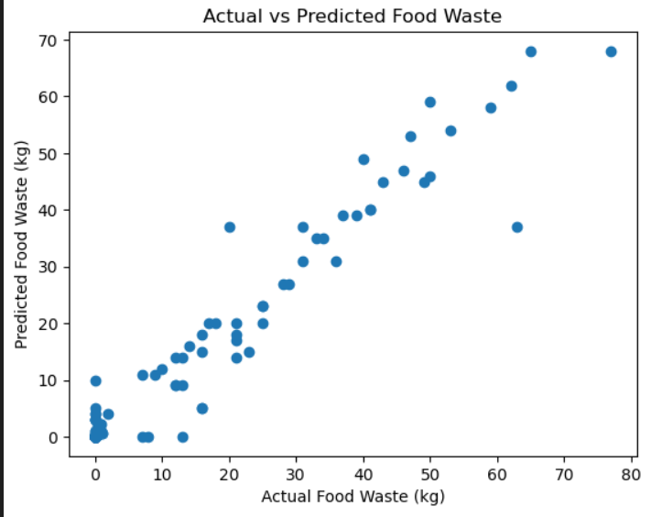

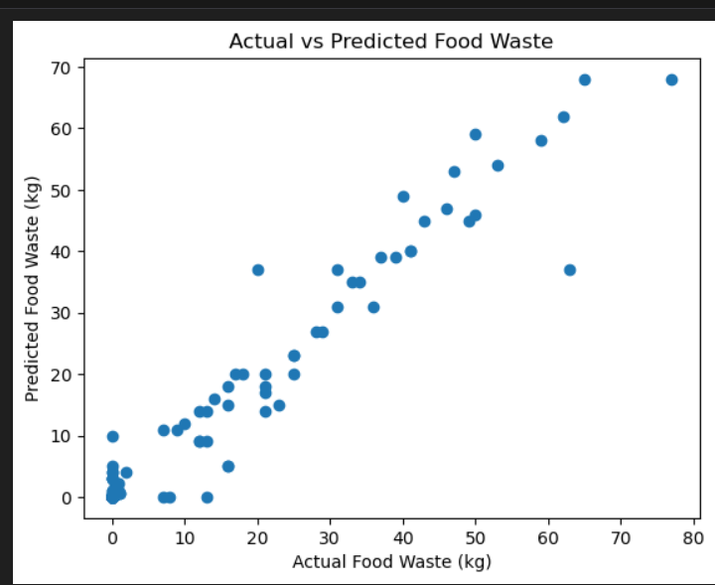

CONCLUSION
The project successfully identifies Random Forest as the most reliable model for predicting food waste in this dataset. By implementing this system, retailers can better anticipate waste and adjust their ordering cycles accordingly. Future work could include integrating real-time sales data to further refine the predictions.
By implementing the Random Forest model, the following benefits can be realized:
- Dynamic Discounting: Retailers can use the model’s "Waste Probability" to trigger automatic discounts on items predicted to become waste within 48 hours.
- Optimized Procurement: The system provides feedback to purchasing managers, suggesting a reduction in order volume for categories that consistently show high predicted waste.
- Carbon Footprint Reduction: Beyond financial savings, the system serves as a sustainability tool, directly contributing to corporate "Zero Waste" goals by preventing physical product loss.
The Food Waste Reduction System demonstrates how machine learning can assist in solving sustainability challenges. By predicting food waste levels using inventory data, retailers can take proactive measures to reduce losses.
The system supports sustainability initiatives aligned with United Nations Sustainable Development Goal 12 (Responsible Consumption and Production).

TEAM COLLABORATION AND MEETING LOGS
Regular group meetings were conducted to ensure systematic progress and collaborative decision-making throughout the project.
Meetings were held on the following dates:
- 26th February 2026
- 27th February 2026
- 2nd March 2026
- 3rd March 2026




